20.25: a) Heat flows out of the 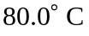 water into the ocean water and the water cools to 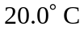 (the ocean warms, very, very slightly). Heat flow for an isolated system is always in this direction, from warmer objects into cooler objects, so this process is irreversible.

- 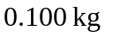of water goes form
This Q comes out of the 0.100 kg of water and goes into the ocean.
For the 0.100 kg of water,
For the ocean the heat flow is 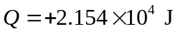and occurs at constant T:
